7 - 4 & 7 - 5 Proportional Lengths HW

Name__________________________
Date_________________Block_____

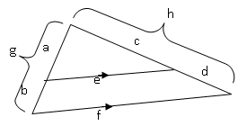
The diagram shows a segment parallel to one side of a triangle. For Exercises 1-4, tell whether the proportion is correct. (Write True or False.)

_______1. $\frac{e}{f}$ = $\frac{a}{g}$ ____________2. $\frac{e}{f}$ = $\frac{c}{d}$

________3. $\frac{b}{a}$ = $\frac{d}{c}$ ________4. $\frac{b}{g}$ = $\frac{c}{h}$

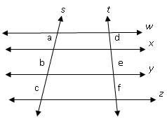
For Exercises 5-8, tell whether the proportion is correct. (Write True or False.)

________5. $\frac{a}{b}$ = $\frac{e}{d}$ ________ 6. $\frac{e}{f}$ = $\frac{b}{c}$

________7. $\frac{e}{d}$ = $\frac{b}{a}$ ________8. $\frac{a}{e}$ = $\frac{d}{b}$

For Exercises 9-18, find the value of x.
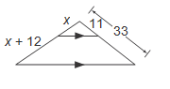
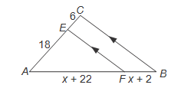
9. 10.

x = _______ x = _______
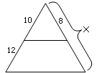
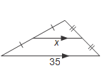
11. 12.

x = _______ x = _______
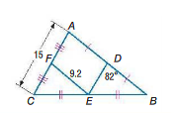
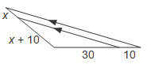
13. 14.

DE = _______
DB = _______ x = _______

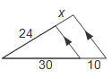
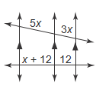
15. 16.

x = _______ x = _______

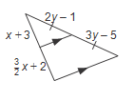
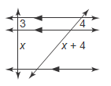
17. 18.

x = _______ x = _______
y = _______
For Exercises 19-24, find x and the indicated measures.

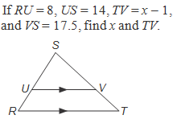
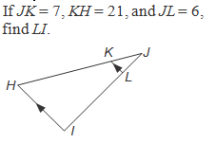
19. 20.

x = _______
TV = _______ LI = _______

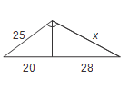
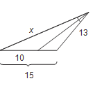
21. 22.

x = _______ x = _______

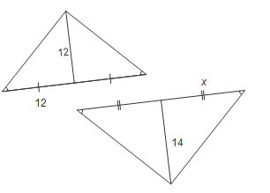
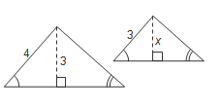
23. 24.

x = _______ x = _______

