2-1 Inductive Reasoning and Conjecture

Inductive reasoning: reasoning that uses a number of specific examples to arrive at a _____________________________.
- You are applying inductive reasoning when you assume that an observed _______________________ will continue.
- A concluding statement reached using inductive reasoning is called a _____________________________________.
- To show that a conjecture is true for all cases, you must prove it.
- It takes only _____ ________________ example to show that a conjecture is not true.
- This false example is called a ________________________________________________________.

EXAMPLES FOR YOU TO PRACTICE:

Observing the following patterns, answer each question.
- A dot pattern is shown below. How many dots would there be in the bottom row of the 4th figure? What would be the total number of dots in the 6th figure?
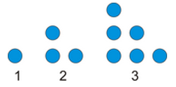

- How many triangles will be in the 10th figure?
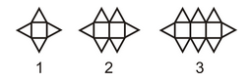

- Use the pattern below to answer the questions.

  - Draw the next figure in the pattern.
  - How does the number of points in each star relate to the figure number?
  - Use part b to determine a formula for the nth figure.

Find a counterexample to show that each conjecture is false.

- Given: John is taking notes in class.

Conjecture: John is using a pencil.

2. Given: An animal is a bird.
Conjecture: It must be an eagle.

- If a number is a prime number, then it must be an odd number.

2-1 Practice Worksheet

1-6: Determine the next 2 terms in the pattern.

- 5, 8, 11, 14, 17,...

- 6, 1, -4, -9, -14,...

- 2, 4, 8, 16, 32,...

- Club meetings: January, March, May, …

- Percent humidity: 100%, 93%, 86%
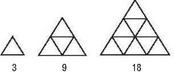

7-9: Make a conjecture about each statement. List or draw some examples that support your conjecture.
- The sum of two odd numbers
- List examples.

- Make a conjecture.

- The sum of an odd and even number
- List examples.

- Make a conjecture.

- The sum of the squares of two consecutive natural numbers.
- List examples.

- Make a conjecture.

10-12: Determine whether each conjecture is true or false. Give a counterexample for any false conjecture.
- If n is a prime number, then n + 1 is not prime.

- If x is an integer, then –x is positive.

- If the area of a rectangle is 20 square meters, then the length is 10 meters and the width is 2 meters.

- If n is a real number, then n² > n.
- The next figure in the sequence is an octagon.

