6-3 Polynomial Functions

Polynomial in
One Variable

A polynomial of degree n in one variable x is an expression of the form
a_{n} x^{n} + a_{n–1}x^{n – 1} + … + a₂ x² + a₁x + a₀, where the coefficients a_{n–1}, a_{n–2}, a_{n–3}, …, a₀ represent real numbers, a_{n} is not zero, and n represents a nonnegative integer.

♥The degree of a polynomial in one variable is the greatest exponent of its variable. ♥The leading coefficient is the coefficient of the term with the highest degree.

Polynomial
Function

A polynomial function of degree n can be described by an equation of the form
P(x ) = a_{n}x^{n} + a_{n–1}x^{n–1} + … + a₂x² + a₁ x + a₀, where the coefficients a_{n–1}, a_{n–2}, a_{n–3}, …, a₀ represent real numbers, a_{n} is not zero, and n represents a nonnegative integer.

♥ The exponents are all whole numbers.
♥ The coefficients and constant are all real numbers.

General/Standard form: The terms are written in descending order
Evaluating a function: If you know an element in the domain of any polynomial function,
you can find the corresponding value in the range.
Example 1
What are the degree and leading coefficient of 3x² – 2x⁴ – 7 + x³?

Rewrite the expression so the powers of x are in decreasing order.
–2x⁴ + x³ + 3x² – 7
This is a polynomial in one variable. The degree is 4, and the leading coefficient is –2.
Lesson 6-3
Original function
Replace x with a² – 1. Evaluate.
Simplify.
g(x) = x² + 3x – 4
g(a² – 1) = (a² – 1)² + 3(a² – 1) – 4
= a⁴ – 2a² + 1 + 3a² – 3 – 4
= a⁴ + a² – 6
Find g(a² – 1) if g(x) = x² + 3x – 4.
Example 3

Original function
Replace x with –5. Evaluate.
Simplify.
f (x) = x³ + 2x² – 10x + 20
f (–5) = (–5)³ + 2(–5)² – 10(–5) + 20
= –125 + 50 + 50 + 20
= –5
Example 2
Find f(–5) if f (x) = x³ + 2x² – 10x + 20.

State the degree and leading coefficient of each polynomial in one variable. If it is not a polynomial in one variable, explain why.

3. 4x⁶ + 6x⁴ + 8x⁸ – 10x² + 20
2. 100 – 5x³ + 10x⁷
1. 3x⁴ + 6x³ – x² + 12

6. $\frac{x^{2}}{18}-\frac{x^{6}}{25}+\frac{x^{3}}{36}-\frac{1}{72}$
5. 8x³ – 9x⁵ + 4x² – 36
4. 4x² – 3xy + 16y²

Given f(x) = 3x² – 9 and g(x) = 4x³ – 3x² + 2x – 1, find each value.

7. f(3a) 8. g(-4) 9. f(x + 2)
Graphs of Polynomial Functions: The general shapes of the graphs of polynomial functions shows the maximum number of times the graph of each function may intersect the x-axis. This is the same number as the degree of the polynomial.
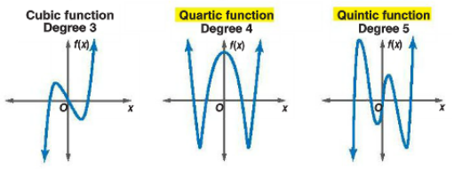
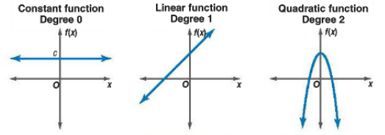

End Behavior of a Polynomial Function:
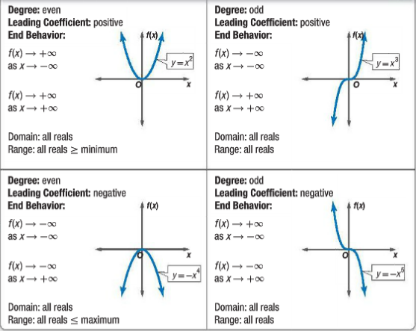
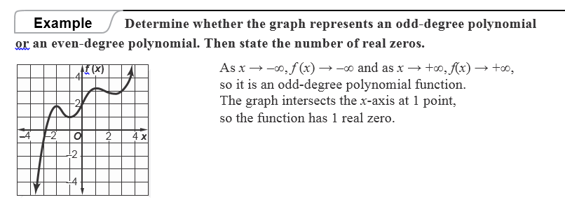
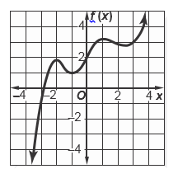

For each graph, do the following:
a. describe the end behavior,
b. determine whether it represents an odd-degree or an even-degree function, and
c. state the number of real zeroes.
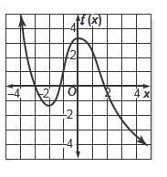
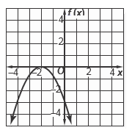
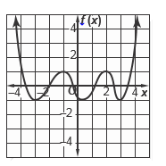
10. 11. 12.

