**Name ______________________________**

Properties of Normal Distribution Homework

**Date ____________________ Block _____**

***Statistics Review***

**1.** Given the data set: {13, 10, 2, 2, 4, 12, 8, 6, 5, 9, 11, 14, 11, 8, 5, 8}

**a.** Find the mean, median, mode, and standard deviation.

**mean:_______ median:_______**

**mode:_______ S.D.:_______**

**b.** Add two different data values to the set that

will not affect the mean, median or mode.

**c.** Construct a histogram of the data

including the data values you added.

**d.** Using a calculator, find the standard deviation of the data set including the new values. ________

**e.** Which values are within 1 standard deviation of the mean?

**f.** Are any data values more than 2 standard deviations from the mean?

**g.** Add two more data values, one above and one below the mean that will increase the standard deviation.

Calculate the new standard deviation.

***z‐score – indicates the location of a data value relative to the mean in terms of standard deviation units.***

**2.** Given a data set where the male adult mean height is 70 inches with a standard deviation of 2.7 inches,

find the following.

**a.** What z‐score would be assigned to a 74 inch male? __________

**b.** What height would have a z‐score of 2? __________

**c.** What height would have a z-score of -3? __________

**d.** Write a formula to determine a value of x for any given z score.

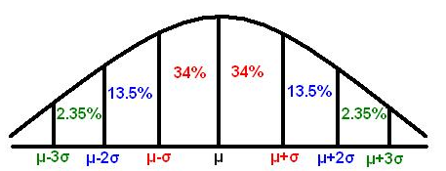

**2 %**

**2 %**

**.5 %**

**.5 %**

***3-5: Draw the appropriate normal distribution graph showing three standard deviations to the left and***

***right of the mean. Then shade the region described.***

**3.** A normal distribution with a mean of 7 and a standard deviation of 2. Shade the area showing the

 probability that a randomly selected item will have a value between 3 and 9.

**4.** The weights of potato chip bags are normally distributed with weights of 10.5 oz. and a standard deviation

of 0.2 oz. Shade the area showing that a randomly selected bag will have a weight less than 10.2 oz.



**5.** The weights of cattle at the fair this year were normally distributed with a mean of 800 lbs with a

standard deviation of 65 lbs. Shade the area showing the probability that a randomly selected cow will

 have a weight less than 735 lbs or greater than 865 lbs.

