1-3 Distance and Midpoint Skills Practice Name___________________________
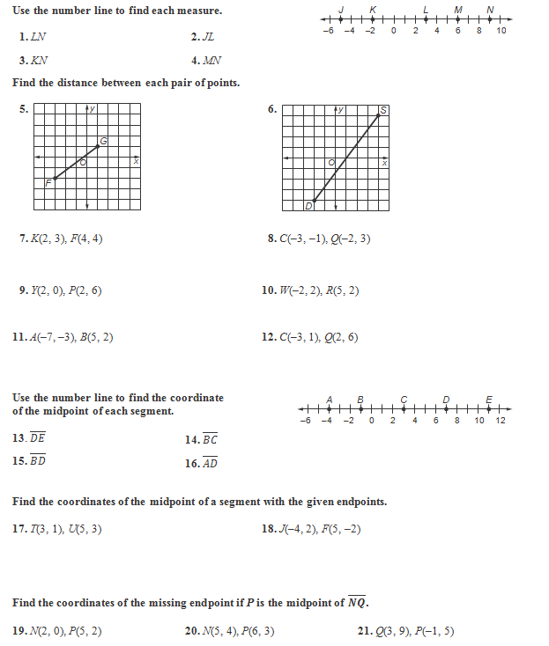
Date__________________Block_____

