Name_____________________________
Date____________________Block_____

Write a compound statement for each conjunction and disjunction. Then find its truth value.
p: 10 + 8 = 18
q: September has 30 days.
r: A rectangle has four sides.
1. p and q .

2. p or r

3. q or r

4. q and ∼r

Use the following statements to write a compound statement for each conjunction and disjunction. Then find its truth value. p: -3 – 2 = -5
q: 3(-2) = 6
r: 2 + 8 > 10
s: 5 – 2 ≤ 7

- p and q

- p ∧ r

- p or s

- r ∨ s

- p ∧ ∼q

- q ∨ ∼r
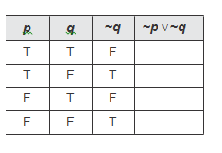
Complete the following truth tables.
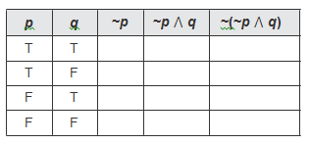
11. 12.

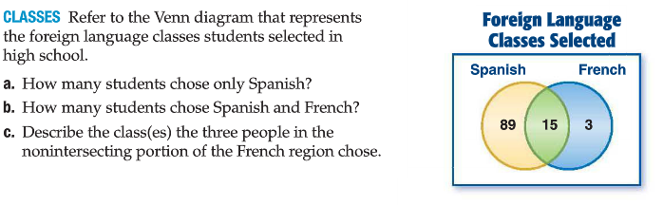
Use the Venn Diagrams to answer the following questions.
13.

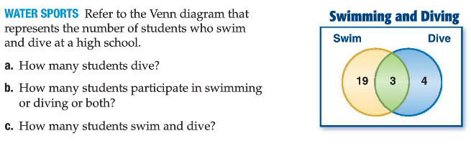
14.

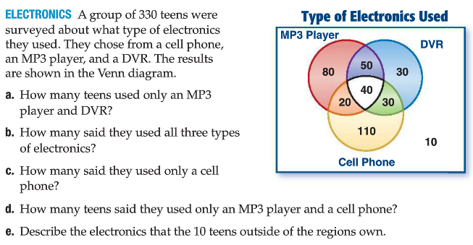
15.

