**Day 03 HW 3-3 Slopes of Lines Practice Name\_\_\_\_\_\_\_\_\_\_\_\_\_\_\_\_\_\_\_\_\_\_\_\_\_\_\_**

**Date\_\_\_\_\_\_\_\_\_\_\_\_\_\_\_\_\_\_Block\_\_\_\_\_**

**1-6: Determine the slope of the line that contains the given points.**

**1.** *J*(0, 0), *K*(–2, 8) **4.** *R*(–2, –3), *S*(3, –5)

**2.** *L*(1, –2), *N*(–6, 3) **5.** *P*(–1, 2), *Q*(–9, 6)

**3.** *T*(1, –2), *U*(6, –2) **6.** *V*(–2, 10), *W*(–4, –3)

|  |  |  |  |  |
| --- | --- | --- | --- | --- |
| **7-11: Use the graph to complete the table below.** | | | | |
|  | **Find the slope of the given line.** | **Find the slope of a line perpendicular to that line.** | **Find the slope of the line parallel to that line.** | **GEO_CH03_020_1.jpg** |
| **7.** |  |  |  |
| **8.** |  |  |  |
| **9.** |  |  |  |
| **10. The x-axis** |  |  |  |
| **11. The y-axis** |  |  |  |

**12-14: Determine if $\overset{⃡}{KM}$ and $\overset{⃡}{ST}$ are *parallel*, *perpendicular*, or *neither by comparing their slopes*.**

**Graph each line to verify your answer.**

**12.** *K*(–1, –8), *M*(1, 6), **13.** *K*(–5, –2), *M*(5, 4), **14.** *K*(–4, 10), *M*(2, –8),

*S*(–2, –6), *T*(2, 10) *S*(–3, 6), *T*(3, –4) *S*(1, 2), *T*(4, –7)

****

**15-20: Graph the line that satisfies each condition.**

**15. y = 2x – 4 16. x = -1 17. y = 3**

**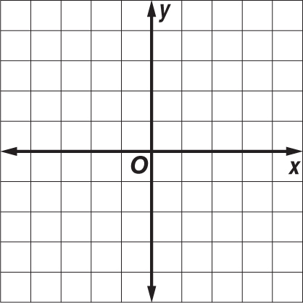**

****

**18. 2x – 4y = 8 19. x + 3y = 12 20. **

****

**21-24: Graph the line that satisfies each condition. 25: Complete the word problem.**

**25. PROFITS** After Take Two began renting DVDs at their video store, business soared. Between 2005 and 2010, profits increased at an average rate of $9000 per year. Total profits in 2010 were $45,000. If profits continue to increase at the same rate, what will the total profit be in 2014?

**21.** slope = – $\frac{1}{2}$, contains *U*(2, –2) **22.** slope = $\frac{4}{3}$, contains *P*(–3, –3)

****

**23.** contains *B*(–4, 2), parallel to **24.** contains *Z*(–3, 0), perpendicular to

$\overset{⃡}{FG}$ with F(0, -3) & G(4, -2) $\overset{⃡}{EK}with E(–2, 4) and K(2, –2)$

****

****