# Name________________________

Day 04 HW Graphing Quadratics in Vertex Form

**Date________________Block____**

*Watch out for the ☺ problems!*

**Graph each function without a calculator. State the vertex and its domain and range in interval notation.**

**1.** y = x2 V( ) **2.** y = (x – 2) 2 V( ) **3.** y = x2 – 2 V( )

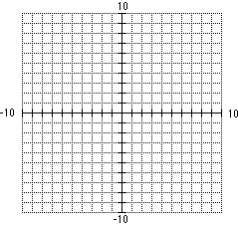

**D:** ___________ **R:** ___________ **D:** ___________ **R:** ___________ **D:** ___________ **R:** ___________

**4.** y = x2 – 3 V( ) **5.** y = -2(x – 3) 2  V( ) **6.** y = 2x2 – 8 V( )



**D:** ___________ **R:** ___________ **D:** ___________ **R:** ___________ **D:** ___________ **R:** ___________

**☺ 7.** y = |x – 6| + 5 V( ) **8.** y = 3(x – 1) 2 – 5 V( ) **9.** y = –x2 + 3 V( )



**D:** ___________ **R:** ___________ **D:** ___________ **R:** ___________ **D:** ___________ **R:** ___________

**10.** y = (x – 1) 2 – 4 V( ) **11.** y = –x2 + 5 V( ) ☺**12.** y = (x + 4) – 8 V( )



**D:** ___________ **R:** ___________ **D:** ___________ **R:** ___________ **D:** ___________ **R:** ___________

☺ **13.** y = (x + 2) – 3 V( ) **14.** y = –2(x + 3)2 V( ) **15.** y =  V( )



**D:** ___________ **R:** ___________ **D:** ___________ **R:** ___________ **D:** ___________ **R:** ___________

**16.** y =  V( ) **17.** y = 2x2 – 6 V( ) ☺ **18.** y = |x – 2| – 4 V( )



**D:** ___________ **R:** ___________ **D:** ___________ **R:** ___________ **D:** ___________ **R:** ___________