8-4 Trigonometry Practice
Name________________________
Date_______________Block_____

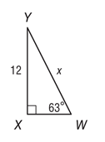
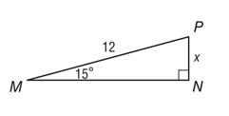
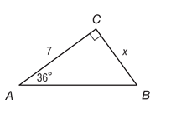
Find the value of x rounded to the nearest tenth. Write an equation for each.
- 2. 3.

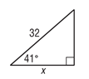
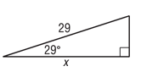
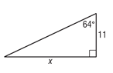
4. 5. 6.

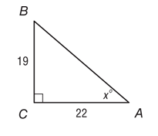
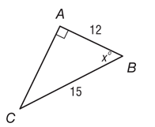
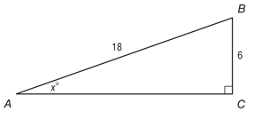
Find the value of x rounded to the nearest degree. Write an equation for each.
7. 8. 9.

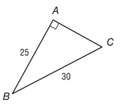
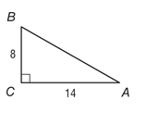
Find the measure of ∠B rounded to the nearest tenth.
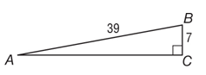
10. 11. 12.

WORD PROBLEMS.
- Diego used a theodolite to map a region of land for his class in geomorphology. To determine the elevation of a vertical rock formation, he measured the distance from the base of the formation to his position and the angle between the ground and the line of sight to the top of the formation. The distance was 43 meters and the angle was 36°. What is the height of the formation to the nearest meter?
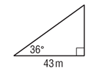

- A 40 foot-long escalator rises from the first floor to the second floor of a shopping mall. The escalator makes a 30° angle with the horizontal. How high above the first floor is the second floor? HINT: Draw a picture!

