Geometry Honors 10-8 Homework Name: _____________________________
Unit 8 Day 7 – Equations of a Circle Date: ________________ Block: _______

1-3: For each circle below, state the coordinates of the center and the length of the radius.

1. (x – 4)² + (y – 2)² = 16 2. (x + 5)² + (y – 8)² = 49 3. (x – 3)² + y² = 25

4-7: Write the equation for each circle described below.

4. center at (3, 5), radius = 6 5. center at (-7, -2), radius = 8 6. center at (0, 0), radius = 1

7. A Doppler radar screen shows concentric rings around a storm. If the center of the radar screen is the origin and each ring is 15 miles further from the center, what is the equation of the third ring?

8-13: Answer the following questions.

8. Dominick’s Pizza and Subs offers free delivery within a 6 mile radius of the restaurant. Consuela’s house is located 4 miles west and 5 miles north of the restaurant.

a. If the restaurant is the origin of the situation, write an equation to represent the delivery region of Dominick’s Pizza and Subs.

b. Can Consuela get free delivery if she orders from Dominick’s? Explain why or why not.

9. Circle O has a center at (-3, -2) and a diameter of 5 units. Which of the following points lies on circle O?
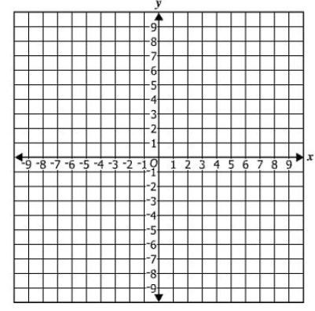
A. (1, 1)
B. (3, 2)
C. (8, 7)
D. (2, 3)

10. Graph the circle with equation (x + 3)² + (y – 2)² = 5²

11. The equation (x + 2)² + (y – 3)² = r² represents circle A. The point B(1, 7) lies on the circle. What is r, the length of the radius of circle A?

A. 11
B.
C. 25
D. 5

12. A circle has a center at (5, -8) and a radius of 6 units. Create the equation of this circle.

The Equation of the Circle

(x + 5) | (x – 5)
(x + 5)² | (x – 5)²
(y + 8) | (y – 8)
(y + 8)² | (y – 8)²
+ | -
3² | 6²

13. Which point lies on the circle represented by the equation (x – 5)² + (y + 1)² = 10²?

A. (11, 7)
B. (10, 10)
C. (0, 7)
D. (8, 6)

