# Day 06 HW: Geometry Honors Test Review Name__________________________

**Unit 3:** **Lines and Their Relationships Date__________________Block____**

|  |  |
| --- | --- |
| **Skill Set 1** | Students will be able to determine the relationships between pairs of lines (parallel, perpendicular, skew  or intersecting), and identify angles formed by pairs of lines cut by a transversal.  For parallel lines,  students will be able to determine if pairs of angles are congruent or supplementary. |

**1-4: Use the diagram to answer each question.**

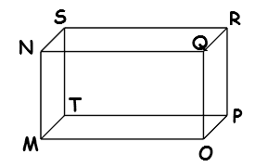

___________________________**1**. Name a plane parallel to MNQ.

___________________________**2.** Name all segments skew to.

___________________________**3.** Name all segments parallel to 

___________________________**4.** State the intersection of planes RPO and RST.

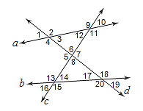**5-9: Name the transversal forming each angle pair. Then identify the type of angles shown.**

**5.** ∠2 and ∠12 ________ ___________________________________

**6.** ∠6 and ∠18 ________ ___________________________________

**7.** ∠13 and ∠19 ________ ___________________________________

**8.** ∠11 and ∠7 ________ ___________________________________

**9.** ∠1 and ∠20 ________ ___________________________________

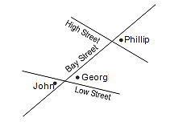**10-11:** **Mark on the given map the answer to each question.**

**10.** Connor lives at the angle that forms an alternate interior

angle with Georg’s residence. Add Connor to the map.

**11.** Quincy lives at the angle that forms a consecutive interior

angle with Connors’ residence. Add Quincy to the map.

|  |  |
| --- | --- |
| **Skill Set 2** | Students will be able to apply the definitions and theorems for parallel and perpendicular lines by using  algebra to find angle measures. |

**12-14: If a || b, find the value of x.** *Show your work and circle your final answer.*

**12.** m∠3 = 2x + 16 & m∠5 = 7x – 4

5 6

7

b

a

t

1

2

3 4 4

8

**13.** m∠4 = 8x - 80 & m∠5 = -2x + 16

**14.** m∠2 = 3x + 19 & m∠6 = 2(x + 10)

**15a - r: If a || b and s || t, find all other angles.** *Fill in ALL angles first using the two given angles!*

16 18 19 20

12 13 14 **95°**

6 7 8 10

**a**

**b**

**t**

**s**

1 2 3 5

**45°**

11

17

9

**m**

**a.** m∠1 = ______ **b.** m∠2 = ______ **c.** m∠3 = ______

**d.** m∠5 = ______ **e.** m∠6 = ______ **f.** m∠7 = ______

**g.** m∠8 = ______ **h.** m∠9 = ______ **i.** m∠10 = ______

**j.** m∠11 = ______ **k.** m∠12 = ______ **l.** m∠13 = ______

**m.** m∠14 = ______ **n.** m∠16 = ______ **o.** m∠17 = ______

**p.** m∠18 = ______ **q.** m∠19 = ______ **r.** m∠20 = ______

|  |  |
| --- | --- |
| **Skill Set 3** | Students will be able to prove lines are parallel or perpendicular using algebraic and coordinate methods, as well as deductive proofs. |

**16: Complete the proof below.**

4

5

**p**

**m**

t

s

2

1

3

7

6

8

**Given:** p || m, s || t **Prove:** ∠2 ≅ ∠4

**a.** p || m, s || t **a._________________________________**

**b.** ∠2 ≅ ∠3 **b. ________________________________**

**c.** ∠3 ≅ ∠4 **c. ________________________________**

**d.** ∠2 ≅ ∠4 **d. ________________________________**

**17-22: Using the diagram in #16, state whether each equation/congruency statement would make any lines parallel. If YES, fill in which lines are parallel and why. If NO, cross through the parallel statement and state why they’re not parallel.**

**17.** m∠6 + m∠8 = 180 ____ || ____ because ______________________________________________________________

**18.** m∠5 + m∠7 = 180 ____ || ____ because ______________________________________________________________ **19.** m∠1 = m∠7 ____ || ____ because ______________________________________________________________ **20.** ∠6 ≅ ∠1 ____ || ____ because ______________________________________________________________ 21**.** m∠5 + m∠8 = 180 ____ || ____ because ______________________________________________________________

**22.** ∠3 ≅ ∠4 ____ || ____ because ______________________________________________________________

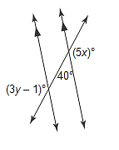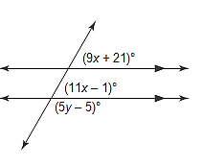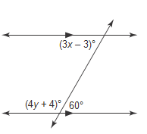 **23-25: Find the value of x and y in each picture.** *Show your algebra below each problem.*

**23.** **24.** **25.**

**x = _________ y = _________ x = _________ y = _________ x = _________ y = _________**

**26-27: Determine whether** **are parallel, perpendicular, or neither by finding their slopes.**

**26.** M(0, 3), N(2, 4), R(2, 1), S(8, 4) **27.** M(–1, 3), N(0, 5), R(2, 1), S(6, –1)

|  |  |
| --- | --- |
| **Skill Set 4** | Students will be able to use coordinate and algebraic methods to write the equation or draw the graph of a line parallel or perpendicular to a given line. |

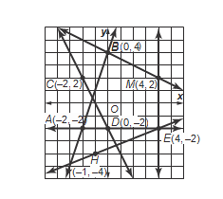

**28-33: Find the slope of each line.**

**28.**  **29.** 

**30.**  **31.** 

**32.**  **33.** 

**34-37: Graph the line that satisfies each condition.**

**34.** …has a slope of 3, passes through A (0, 1) **35.** …has a slope of $-\frac{3}{2}$, passes through R (–4, 5)

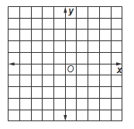

**36.** …passes through Y (3, 0), parallel to  **37.** …passes through T (0, –2), perpendicular

with D(–3, 1) and J(3, 3) to with C(0, 3) and X(2, –1)



**38-41: Write the equation of the line with the given characteristics in slope-intercept form.**

**38. …**has a slope of $\frac{2}{3}$ and a y-intercept of –10 **39.** …has a slope of $\frac{3}{2}$ and contains (4, 6)

**40.** …whose*x*-intercept is –6 and *y*-intercept is 2 **41. …**contains (–4, 2) and (8, –1)

|  |  |
| --- | --- |
| **Skill Set 5** | Students will be able to construct a line perpendicular to a given line through (a) a point not on the line  and (b) through a point on the line, and construct a line parallel to a given line through a given point. |

**42-45: Do the following constructions.**

**42.** Construct perpendicular to . **43.** Construct the perpendicular bisector of 

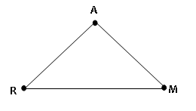

**X**

**Y**

**44.** Construct  parallel to line w **45.** Construct  perpendicular to 

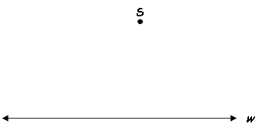

**L**

**M**

**C**

**S**

***w***