Name__________________________
Geometry Honors Unit 2, Day 07 HW
2-7 Proving Segment Relationships
Date________________Block______
1-9: Justify each statement with a property of equality, a property of congruence, or a postulate.
1. QA = QA

2. If AB = CD, then .

3. If $\overline{AB}$ ≅ $\overline{BC}$ and $\overline{BC}$ ≅ $\overline{CE}$ then $\overline{AB}$ ≅ $\overline{CE}$.

4. If Q is between P and R, then PQ + QR = PR

5. If AB + BC = EF + FG and AB + BC = AC, then EF + FG = AC.

6. If MN = PQ, then MN + RS = PQ + RS.

7. If B is the midpoint of, then AB = BC.

8. If AB = CD, then CD = AB.

9. If AB + BD = AD and BD = RS, then AB + RS = AD.

10-11: Complete each proof.
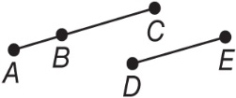  10. Given: BC = DE  Prove: AB + DE = AC  Statements Reasons  1. BC = DE 1. ________________  2. _______________ 2. Seg. Add. Post.  3. AB + DE = AC 3. ________________ | 11. Given: $\overline{AB}$ ≅ $\overline{CD}$  Prove: $\overline{CD}$ ≅ $\overline{AB}$  Proof:  Statements Reasons  a. __________ a. Given  b. AB = CD b. _______________________  c. CD = AB c. _______________________  d. ________ d. Definition of ≅ segments

12-13: Complete each proof.

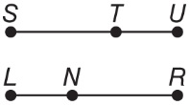
12. Given: $\overline{SU}$ ≅ $\overline{LR}$
$\overline{TU}$ ≅ $\overline{LN}$
Prove: $\overline{ST}$ ≅ $\overline{NR}$

Statements | Reasons
a. $\overline{SU}$ ≅ $\overline{LR}$, $\overline{TU}$ ≅ $\overline{LN}$ | a. _________________________________________
b. _______________________________________ | b. Definition of ≅ segments
c. SU = ST + TU  LR = LN + NR | c. _________________________________________
d. ST + TU = LN + NR | d. _________________________________________
e. ST + LN = LN + NR | e. _________________________________________
f. ST + LN – LN = LN + NR – LN | f. _________________________________________
g. _______________________________________ | g. Substitution Property
h. $\overline{ST}$ ≅ $\overline{NR}$ | h. _________________________________________

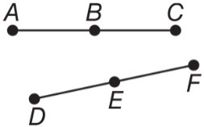
13. Given: $\overline{AB}$ ≅ $\overline{DE}$
B is the midpoint of $\overline{AC}$ .
E is the midpoint of $\overline{DF}$ .
Prove: $\overline{BC}$ ≅ $\overline{EF}$

Statements | Reasons
a. ________________________________________  _________________________________________  _________________________________________ | a. Given
b. AB = DE | b. _________________________________________
c. ________________________________________  _________________________________________ | c. Definition of Midpoint
d. BC = DE | d. _________________________________________
e. BC = EF | e. _________________________________________
f. ________________________________________ | f. _________________________________________

