Name:_____________________
Date____________Block_____

1-9: Using the theorems learned in class, find the measure of each numbered angle.

1. m∠2 = 57 2. m∠5 = 22 3. m∠1 = 38
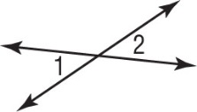
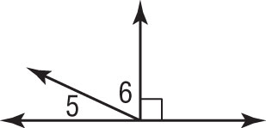
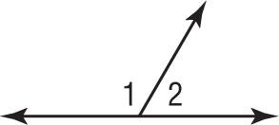

m∠1 = _______ m∠6 = _______ m∠2 = _______

4. m∠13 = 4x + 11, 5. ∠9 and ∠10 are complementary. 6. m∠2 = 4x – 26,
m∠14 = 3x + 1 ∠7 ≅ ∠9, m∠8 = 41 m∠3 = 3x + 4
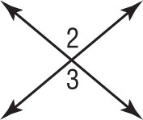
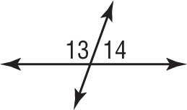
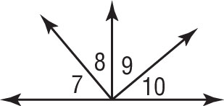

Algebra: Algebra: Algebra:

x = _______ m∠7 = _______ x = _______

m∠13 = _______ m∠9 = _______ m∠2 = _______

m∠14 = _______ m∠10= _______ m∠3 = _______

7. m∠1 = x + 10 8. m∠4 = 2x – 5 9. m∠6 = 7x – 24
m∠2 = 3x + 18 m∠5 = 4x – 13 m∠7 = 5x + 14
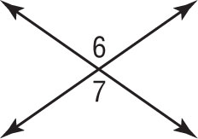
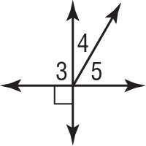
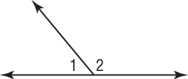

Algebra: Algebra: Algebra:

x = _______ x = _______ x = _______

m∠1 = _______ m∠4 = _______ m∠6 = _______

m∠2 = _______ m∠5= _______ m∠7 = _______
10-11: Refer to the figure to answer the following question.
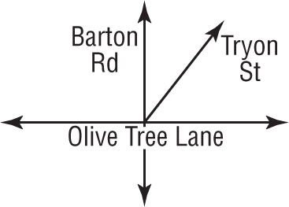
Given: Barton Road and Olive Tree Lane form a right angle at their
intersection. Tryon Street forms a 57° angle with Olive Tree Lane.

10. What is the measure of the acute angle Tryon Street forms with Barton Road?

11. What theorem, definition, or postulate helped you to answer question #10?

12-13: Complete the proofs with the correct statements and/or reasons.

12.  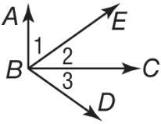  Given: $\overline{AB}$ ⊥ $\overline{BC}$;  ∠1 and ∠3 are  complementary.  Prove: ∠2 ≅ ∠3  Statements Reasons  a. $\overline{AB}$ ⊥$\overline{BC}$ a. _________________  b. ________________ b. Definition of ⊥  c. m∠ ABC = 90 c. Def. of right angle  d. m∠ ABC =m∠1 + m∠2 d. _________________  e. 90 = m∠1 + m∠2 e. Substitution  f. ∠1 and ∠2 are complementary. f. _________________  g. ________________ g. Given  h. ∠2 ≅ ∠3 h. _________________ | 13.  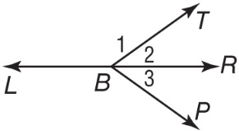  Given: ∠1 and ∠2 form a linear pair.  m∠1 + m∠3 = 180  Prove: ∠2 ≅ ∠3  Statements Reasons  a. ∠1 and ∠2 form a linear pair. m∠1 + m∠3 = 180 a. Given  b. m∠1 + m∠2 = 180 b. ___________________ ___________________  c. m∠1 + m∠3 = m∠1 + m∠2 d. ___________________ e. m∠3 = m∠2 f. m∠2 = m∠3 g. ∠2 ≅ ∠3 c. ___________________ d. Subtraction P.O.E. e. ___________________ f. ___________________ g. ___________________

