# Algebra 2 & Trigonometry Test Review Name: _____________________________

**Unit 2A – Quadratic Functions and Relations Date: __________________ Block: ______**

**Target 1**: State the domain and range of any relation or function in set builder and interval notation.

1-4: Determine if each graph is a function. State the domain and range of each using set builder notation.

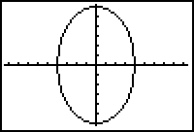

2

2

**1.** **Function? Yes No 2. Function? Yes No**

**D: ________________ D: ________________**

**R: ________________ R: ________________**

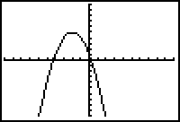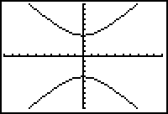

**3.** **Function? Yes No 4. Function? Yes No**

**D: ________________ D: ________________**

**R: ________________ R: ________________**

**5-7: Write the domain and range each function in interval notation.**

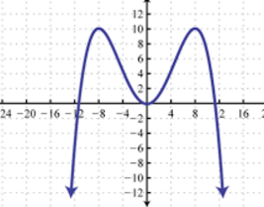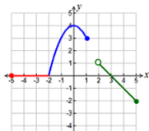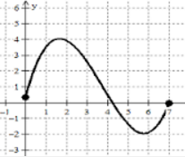

**5.**  **6. 7.**

**D: ________________** **D: ________________ D: ________________**

**R: ________________ R: ________________ R: ________________**

**Target 2**: Graph a quadratic function, and state all of its parts (vertex, roots/zeros, intercepts, axis of symmetry, domain and range) in any form (standard, vertex, intercept) with and without a graphing calculator.

**8-10: Graph each function and fill in the blanks below. Write the domain and range in interval notation.**

1. y = -2x2 + 4x + 6 **vertex: _____________ Is it a maximum or minimum?**

*Circle one.*

**Equation in vertex form: ______________________________________**

**y-intercept: _______________ axis of symmetry: ____________**

**domain: _______________ range: _______________**

**roots/zeros: _______________________**

**Equation in intercept form: ____________________________________**

1. y = 2(x + 5)(x + 1) **vertex: _____________ Is it a maximum or minimum?**

*Circle one.*

**Equation in vertex form: ______________________________________**

**y-intercept: _______________ axis of symmetry: ____________**

**domain: _______________ range: _______________**

**roots/zeros: _______________________**

**Equation in general form: ____________________________________**

1. y = (x – 3)2 **vertex: _____________ Is it a maximum or minimum?**

*Circle one.*

**y-intercept: _______________ axis of symmetry: ____________**

**domain: _______________ range: _______________**

**roots/zeros: _______________________**

**Equation in intercept form: ____________________________________**

**Equation in general form: ____________________________________**

**Target 3:** Apply knowledge of quadratics in real-life contexts (using the graphing calculator)

**11-13: Draw a sketch of each scenario. Then use the calculator to find each answer.**

*Round decimal answers to the nearest hundredth.*

**11.** An object is released into the air at an initial height of 9 feet and an initial velocity of 30 feet per second.

The object is caught at a height of 10 feet. Use the vertical motion model, h = -16t2 + v0 t + h0, where

*h* is the height, *t* is the time in motion, *h0* is the initial height, and *v0* is the initial velocity.

1. Write the equation for the model of this function.
2. How long the object is in motion?
3. What was the maximum height of the object?
4. If the ball wasn’t caught in the air, how long would it take for it to hit the ground?

**12.** Lauren is trapped in a building 120 feet above the ground and wants to land on a rescue team’s air

cushion. Lauren’s height is modeled by h = -16t2 + h0, where *t* is time and *h0* is initial height.

1. How long before Lauren reaches safety?
2. What was the highest Lauren jumped before she landed on the air cushion?

**13.** A study compared the speed *x* (in miles per hour) and the average fuel economy *y* (in miles per gallon)

for cars. The results are shown in the table.

|  |  |  |  |  |  |  |  |  |  |  |  |  |
| --- | --- | --- | --- | --- | --- | --- | --- | --- | --- | --- | --- | --- |
| **Speed, *x*** | 15 | 20 | 25 | 30 | 35 | 40 | 45 | 50 | 55 | 60 | 65 | 70 |
| **Fuel economy, *y*** | 22.3 | 25.5 | 27.5 | 29.0 | 28.8 | 30.0 | 29.9 | 30.2 | 30.4 | 28.8 | 27.4 | 25.3 |

1. Use a graphing calculator to view the scatterplot of the data. Then find the best-fitting quadratic model

for the data and write it in the blank below rounded to the nearest thousandth.

________________________________________________

**b.** Find the speed that maximizes a car’s fuel economy. ______________________

**c.** Predict what the gas mileage would be if the speed was 63 miles per hour. ______________________

**Target 4:** Factor quadratic expressions and solve a quadratic equation over the set of real numbers by

factoring.

**14-19: Factor each polynomial completely. Circle your final answer.**

**14.** 2x2 + 14x – 36 **15.** 2x2 – 3x – 5 **16.** 4z2 + 4z – 15

**17.** 16c2 – 100 **18.** 12x2yz – 6xy2z2 + 3xyz **19.** 4p2 + 4p – 24

**20-28: Solve each equation by factoring. Circle your final answer.**

**20.** 3x2 = 10 – 13x **21.** x2+ 12x + 36 = 4 **22.** 6 = x2 – x

**23.** 4x2 + 1 = 26 **24.** 9x2 + 30x + 25 = 0 **25.** x2 – 4x = 5

**26.** 4x2 – 20x = 0 **27.** 2x2 + 5x – 3 = 0  **28.** 36x2 = 25

# 29-31: Write a quadratic function in general form for the information given.

**29.** roots: x =  **30.** roots: x =   **31.** roots: x = 

______________________ ______________________ ______________________