Name____________
Date______Block____

10-1, 10-2 & 11-3 Practice Worksheet

1-2: The diameters of ⨀L and ⨀M are 20 and 13 units, respectively, and QR = 4. Find each measure.
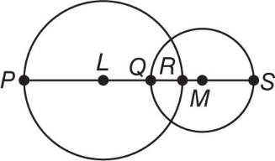
1. LQ = ________ 2. RM = ________

3-4: Find the diameter and radius of a circle with the given circumference. Round to the nearest hundredth.

3. C = 21.2 ft r = __________ 4. C = 5.9 m r = __________

d = __________ d = __________
5-6: Find the exact circumference and area of each circle using the given inscribed or circumscribed polygon.
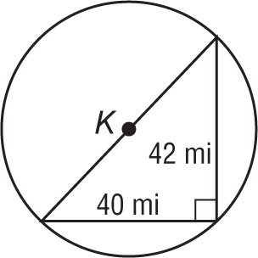
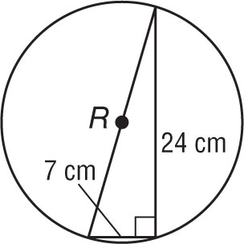
5. 6.

C = ________= ________ C = ________= ________

A = ________= ________ A = ________= ________
7-10: Find the indicated measure. Round to the nearest tenth.
7. The area of a circle is 3.14 square centimeters. Find the diameter.

8. Find the radius of a circle with an area of 855.3 square millimeters.

9. The area of a circle is 201.1 square inches. Find the Circumference.

10. Find the radius of a circle with a circumference of 2290.2 feet.

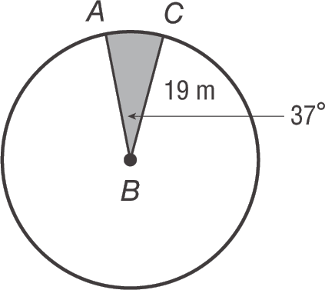
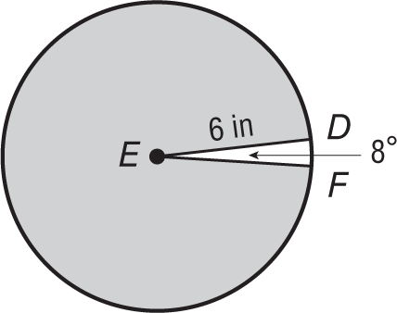
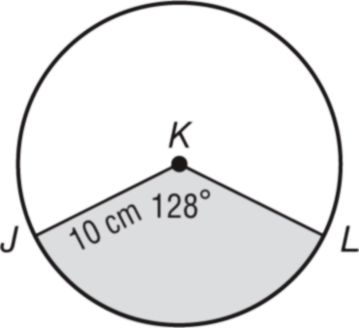
11-13: Find the arc length and area of each shaded sector. Round to the nearest tenth.
11. 12. 13.

l = _____________= ___________ l = ____________= ___________ l = ____________= ___________

A = ____________= ___________ A = ____________= __________ A = ____________= ___________

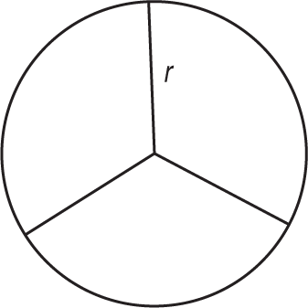
14-18: Real-world Application problems.
- In the symbol shown, a circle separated into 3 equal sectors, has come to symbolize peace.
Suppose the circle has radius r. What is the formula for the area of each sector?

- Sadie wants to draw a clock face on a circular piece of cardboard. If the clock face has a diameter of 20 centimeters and is divided into congruent pieces so that each sector is 30°, what is the area of each piece?

- Julie needs to cover the top and bottom of a can of soup with construction paper for her art project. Each circle has a diameter of 7.5 centimeters. What is the total area of the can that Julie must cover rounded to the nearest integer?

- Herman purchased a sundial to use as his garden centerpiece. The diameter of the sundial is 9.5 inches.
a. Find the radius of the sundial.

b. Find the circumference of the sundial to the nearest hundredth.

- A circular pool is surrounded by a circular sidewalk that is 3 feet wide. The diameter of the sidewalk and pool is 26 feet.
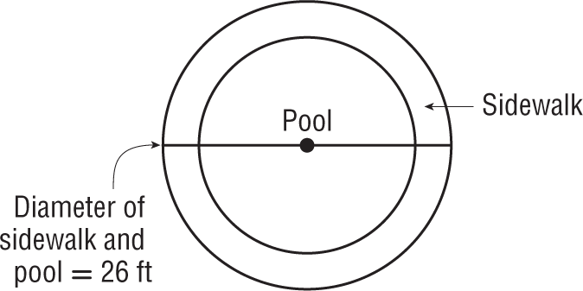
a. What is the diameter of the pool?

b. What is the area of the sidewalk and pool?

c. What is the area of the pool?

