Geometry Part 2 Name ___________________________
SOL Reporting Category 1: Reasoning, Lines, and Transformations

Choose the best answer for each question.

Use the diagram for questions 1 – 3.
Line r and lines are parallel. The measure of 1 is 82°.
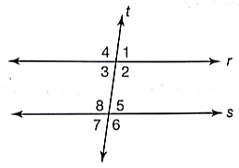
- What is the measure of 6?

- 8°
- 82°
- 98°
- 108°

- Which angles are supplementary?

- 1 and 3
- 2 and 3
- 3 and 5
- 4 and 6

- Which statement is not true?

- 1 and 4 are congruent angles.
- 3 and 6 are supplementary angles.
- The sum of m2 and m7 is 180°.
- 5 and 8 form a linear pair.

- Two lines are cut by a transversal. Which of the following is enough to show that the two lines are parallel?

- Two vertical angles are congruent.
- Two corresponding angles are supplementary.
- Two angles for a linear pair.
- Two alternate interior angles are congruent.
Use the diagram below for questions 5 – 7.
Line g and line h are cut by a transversal, line k.
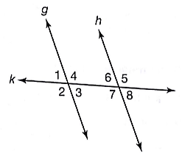

- If m3 = 74°, m4 = 106°, and m6 = 68°, which of the following statements must be true?

- Line g is parallel to line h.
- Line g is not parallel to line h.
- 3 8
- 3 and 7 are supplementary.

- Which of the following statements would be enough information to show that line g is parallel to line h?

- m3 = m1
- m3 = m5
- m3 = 81°, m5 = 99°
- m3 = 81°, m4 = 99°

- If line g is parallel to line h and m4 = 112°, which of the following must be true?

- m7 = 61°
- m7 = 78°
- m7 = 90°
- m7 = 112°

- A fence consists of parallel horizontal wires and slanted wooden fence posts at different angles.
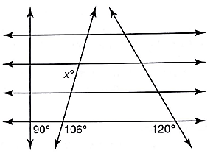
What is the value of x in the diagram above?

- 60°
- 74°
- 90°
- 106°

- Two parallel lines are cut by a transversal. If a pair of same-side interior angles are congruent, what is the measure of each of the two angles?

Angle 1 = _______ Angle 2 = _______

- Which of the following can be used to show that lines l and m are not parallel to each other?
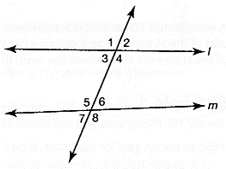

- Show that the sum of the measures of angles 2 and 7 is less than 180°.
- Show that the sum of the measures of angles 3 and 6 is less than 180°.
- Show that the sum of the measures of angles 3 and 7 is less than 180°.
- Show that the sum of the measures of angles 4 and 6 is less than 180°.

- Lines l and m are intersected by line p.
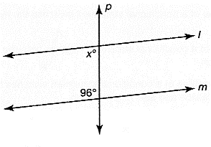
For lines l and m to be parallel, what must be the value of x?

x = __________

- What is the slope of $\overline{MN}$?
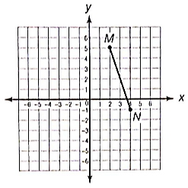
- -3
- -2
- $-\frac{2}{3}$
- $-\frac{3}{2}$

- What is the slope of a line that passes through (9, -8) and (-3, 12)?

- $-\frac{5}{3}$
- $-\frac{3}{5}$
- $\frac{3}{10}$
- $\frac{10}{3}$

- What is the slope of a line that is perpendicular to the line whose equation is y = -x – 2?

- -1
- 0
- ½
- 1

- Look at the line graphed below.
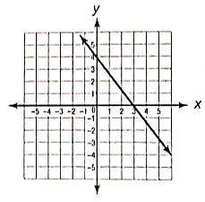
Which equation represents a line that is parallel to the line shown?

- y = $\frac{4}{3}$ x + 2
- y = $-\frac{3}{4}$ x
- y = $-\frac{4}{3}$ x – 3
- y = $\frac{3}{4}$ x – 4

- Which equation represents a line that is perpendicular to the line whose equation is 3x – 5y = 15?

- y = $\frac{5}{3}$ x + 4
- y = $\frac{3}{5}$ x + 4
- y = $-\frac{3}{5}$ x + 4
- y = $-\frac{5}{3}$ x – 4

- Which line segments are parallel?
  - $\overline{MN}$ with M(-3, 7) and N(6, -5)
  - $\overline{PQ}$ with P(5, -4) and Q(9, -1)
  - $\overline{TU}$ with T(-2, -4) and U(-8, 4)

- I and II only
- I and III only
- II and III only
- I, II, and III

- If ABCD is a rectangle graphed on the coordinate plane, how does the slope of $\overline{AB}$ compare to the slope of $\overline{CD}$?

- The slope of $\overline{AB}$ is equal to the slope of $\overline{CD}$.
- The slope of $\overline{AB}$ is the opposite of the slope of $\overline{CD}$.
- The slope of $\overline{AB}$ is the reciprocal of the slope of $\overline{CD}$.
- The slope of $\overline{AB}$ is the opposite reciprocal of the slope of $\overline{CD}$.

- Which equation represents a line that intersects y = $-\frac{1}{4}$ x – 6 at exactly one point?

- 4y = -x
- –y = $\frac{1}{4}$ x – 3
- y = $-\frac{2}{8}$ x + 3
- y = $-\frac{3}{9}$ x + 6

- Triangle DEF has vertices D(0, 4), E(6, 2), and F(3, -7). Is ΔDEF a right triangle? Why or why not?

- What is the length of $\overline{AB}$ with endpoints A(-2, 3) and B(1, 2)?

- $\sqrt{2}$ units
- 2 units
- $\sqrt{10}$ units
- 10 units
Use the figure below for questions 22 and 23.
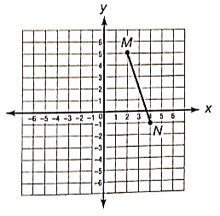

- What is the length of $\overline{MN}$?

- $\sqrt{34}$
- $2\sqrt{10}$
- 8
- $6\sqrt{2}$

- What is the midpoint of $\overline{MN}$?

- (0.5, 3.5)
- (1, 3)
- (3, 2)
- (3.5, 1.5)

- Point C is the midpoint of $\overline{AB}$. Point D is the midpoint of $\overline{CB}$. If CD = 4 units, what is the length of $\overline{AB}$?

- 1 unit
- 2 units
- 8 units
- 16 units

- Point C is the midpoint of $\overline{AB}$ with endpoints A(-2, 2) and B(1, -3). What is the length of $\overline{AC}$?

- $\frac{\sqrt{2}}{2}$ unit
- $\frac{1}{2}$ unit
- $\frac{\sqrt{34}}{2}$ units
- $\sqrt{34}$ units

- Point F is the midpoint of $\overline{DE}$. Given D(3, 5) and F(0, 1), what are the coordinates of point E?

- (-5, -5)
- (-3, -3)
- (1.5, 2)
- (3, 1)

Use the following information for questions 27 and 28.

On the map below, Town Hall is located at the point (0, 0). Each unit on the grid represents 1 km. Allen lives 3 km east and 2 km north of Town Hall. Bartholomew lives 11 km east and 8 km north of Town Hall.
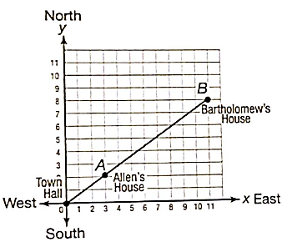

- Allen and Bartholomew plan to meet exactly halfway between their houses. What are the coordinates of the location where they should meet?

- (5, 7)
- (6, 5)
- (7, 4)
- (7, 5)

- What is the straight-line distance between Allen’s house and Bartholomew’s house?

- $\sqrt{10}$ km
- $\sqrt{28}$ km
- 10 km
- 28 km

- Point S lies on segment $\overline{QR}$. Point S has coordinates (-5, 0), point Q has coordinates (-8, -3), and QR = $6\sqrt{2}$. Verify that S is the midpoint of $\overline{QR}$. Show your work.

- How many lines of symmetry does the figure have?

- 0
- 1
- 2
- 3

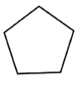
- How many lines of symmetry does a regular pentagon have?

- 2
- 3
- 4
- 5

- Which of the figures below does not have point symmetry?

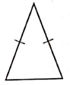
- . C.

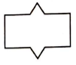
- . D.

- What kind of symmetry does the figure have?
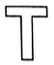
- Point symmetry and line symmetry
- Point symmetry only
- Line symmetry only
- No symmetry
- ΔDEF has coordinates D(5, 2), E(5, -2), and F(-4, 0). Which of the following statements is true about ΔDEF?

- The triangle has o lines of symmetry.
- Both the x-axis and y-axis are lines of symmetry.
- The x-axis is the only line of symmetry.
- The y-axis is the only line of symmetry.

- Quadrilateral LMNO has coordinates L(0, 4), M(5, 0), N(0, -3), and O(-6, 0). What kind of symmetry does LMNO have?

- No symmetry
- Point symmetry only
- Line symmetry only
- Point symmetry and line symmetry

- How many lines of symmetry does the equilateral triangle have? Draw the lines of symmetry on the figure below.

__________

- Jessica constructed segment LP by setting her compass span to the length of segment JK.
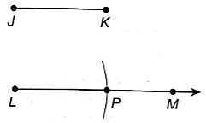
Which statement must be true about this construction?

- Line segments JK and LP are congruent.
- Line segments JK and LM are congruent.
- Line segments JK and PM are congruent.
- Point P is the midpoint of $\overline{LM}$.

- The diagram below shows two steps in a construction. One step shows the distance between points C and E being measured on CDE with a compass. The second step shows the same compass span being used to swing an arc from point E’. Which construction is being performed?
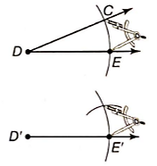

- Copying a line segment
- Drawing the perpendicular bisector of a line segment
- Copying an angle
- Drawing an angle bisector

Use the diagram for questions 39 and 40.
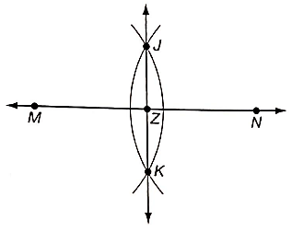
- Which construction is shown above?

- Copying a line segment
- Drawing the bisector of a line segment
- Copying an angle
- Drawing an angle bisector

- Which statement must be true of the construction shown above?

- Point Z is the midpoint of $\overline{MN}$.
- Point M is the midpoint of $\overline{MN}$.
- $\overline{MN}$ is congruent to $\overline{JK}$.
- $\overline{MN}$ is congruent to $\overline{JZ}$.
- Hector is drawing architectural blueprints for a building. In the blueprints, RST is a right angle representing the corner of a room.
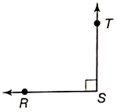
Hector wants to draw a new angle, XYZ, that measures exactly 45° to use elsewhere in the blueprints. Which of the following constructions should he use?

- Copying RST only
- Bisecting $\overline{ST}$ only
- Constructing the perpendicular bisector of $\overline{ST}$ and then copying $\overline{ST}$
- Constructing the angle bisector of RST and then copying one of the resulting 45° angles

- Anoki used a compass and straightedge to construct the figure below.
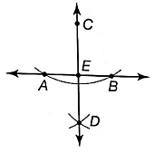
Which statement is not true about the diagram?

- $\overline{AB}$ is congruent to $\overline{CD}$.
- $\overline{AE}$ is congruent to $\overline{BE}$.
- AEC and BEC are both right angles.
- AED and BED are both right angles.

