Geometry Part 2 Name ___________________________
SOL Reporting Category 2: Triangles

Choose the best answer for each question.

Use ΔXYZ to answer questions 1 and 2.
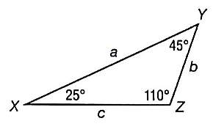
- Which of the following best describes ΔXYZ?

- Acute isosceles triangle
- Acute scalene triangle
- Obtuse isosceles triangle
- Obtuse scalene triangle

- Which statement about this triangle is true?

- Side XZ is the shortest side.
- Side YZ is the shortest side.
- Side XZ is the longest side.
- Side YZ is the longest side.

- Amandine is making a pizza in the shape of a triangle. One side is 12 inches long, and another side is 24 inches long. Which of the following could be the length of the third side?

- 40 in.
- 36 in.
- 26 in.
- 10 in.

- What is the measure of each angle in an equiangular triangle?

- 30°
- 45°
- 60°
- 90°

Use ΔGHI below to answer questions 5 and 6.
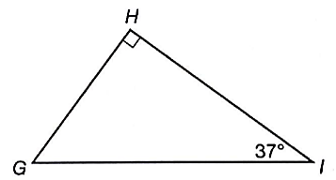

- What is m∠G?

- 53°
- 63°
- 90°
- 143°

- Which of the following inequalities shows the correct relationship between the sides of ΔGHI?

- HI < GH < GI
- GH < GI < HI
- GI < HI < GH
- GH < HI < GI

- Two sides of a triangle measure 21 inches and 23 inches. If the third side of the triangle measures x inches, which of the following shows the range of possible values for x?

- 0 < x < 44
- 0 < x < 21
- 2 < x < 23
- 2 < x < 44

- Which of the following could not be the lengths of the three sides of a triangular garden?

- 18 ft, 30 ft, 12 ft
- 16 ft, 16 ft, 30 ft
- 15 ft, 28 ft, 14 ft
- 18 ft, 18 ft, 18 ft

- The diagram below shows the triangular route of an airplane. Order x, y, and z from smallest to largest.
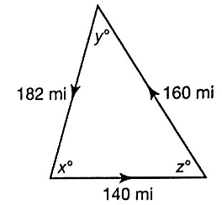

_______, _______, _______

In questions 10-13, if the triangles are congruent, state which method can be used to prove the triangles congruent. If they are not necessarily congruent, choose “not congruent.”

- The figure below is formed by two intersecting segments whose endpoints are connected by two additional segments.
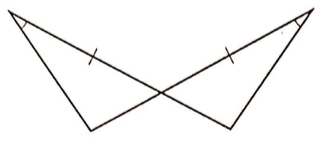

- SSS
- ASA
- SAS
- Not congruent

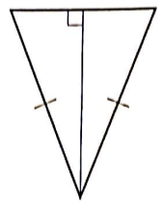
- .

- HL
- SSS
- ASA
- Not congruent

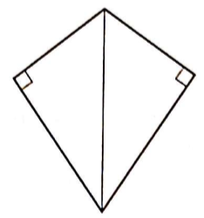
- .

- HL
- ASA
- SSS
- Not congruent

- In the figure below, C is the midpoint of $\overline{AD}$. Consider ΔABC and ΔDBC.
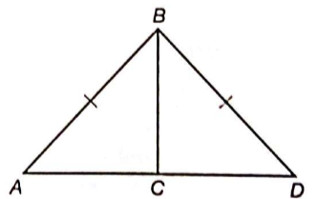

- SSS
- ASA
- SAS
- Not congruent

- If ΔABC ≅ ΔDEF and $\overline{CB}$ corresponds to $\overline{FE}$, which angle corresponds to ∠CAB?

- ∠ABC
- ∠FDE
- ∠DEF
- ∠FED

In questions 15-17, choose the answer that completes the proof.

Given: B is the midpoint of $\overline{AC}$, $\overline{AT}$ ≅ $\overline{BX}$, and $\overline{AT}$ || $\overline{BX}$.
Prove: ΔABT ≅ ΔBCX
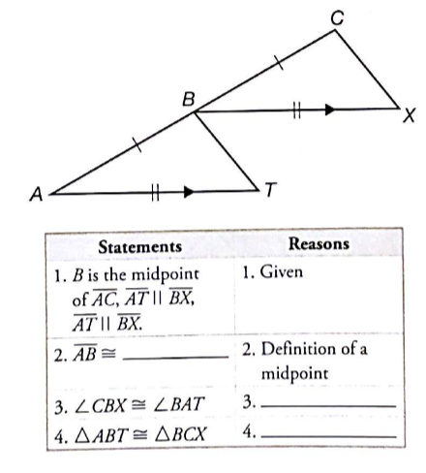

- What is the missing part of Statement 2?

- $\overline{BA}$
- $\overline{BT}$
- $\overline{BC}$
- $\overline{AT}$

- What is the missing reason for Step 3?

- Alternate interior angles theorem
- Corresponding angles theorem
- Alternate exterior angles theorem
- Reflexive property

- What is the missing reason for Step 4?

- SSS congruence postulate
- AAS congruence theorem
- ASA congruence postulate
- SAS congruence postulate

- In the diagram below, $\overline{AB}$ ≅ $\overline{CB}$ and $\overline{BD}$ is perpendicular to $\overline{AC}$. Is ΔABD ≅ ΔCBD? Why or why not?
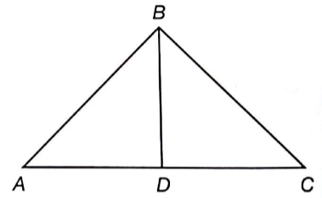

_________________________________________________________________________________________________________________________________

- Which triangles are always similar?

- isosceles
- right
- equilateral
- acute

- Which of the following statements is always true about similar triangles?

- Similar triangles have parallel bases.
- Similar triangles have the same shape.
- Similar triangles are the same size.
- Similar triangles have congruent sides.

Use the diagram for questions 21-23.
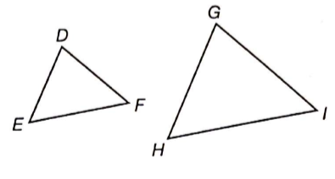
- If ΔDEF ~ ΔGHI, DE = 4 units, DF = 6 units, and GH = 10 units, what is the length of $\overline{GI}$?

- 2.4 units
- 6.7 units
- 12 units
- 15 units

- Given $\frac{DE}{GH}$ = $\frac{EF}{HI}$, what other piece of information would you need to prove ΔDEF ~ ΔGHI?

- ∠F ≅ ∠I
- ∠E ≅ ∠H
- $\overline{DE}$ ≅ $\overline{GH}$
- $\overline{DF}$ ≅ $\overline{GI}$

- Given ∠D ≅ ∠G, what other information would not help in proving ΔDEF ~ ΔGHI?

- ∠E ≅ ∠H
- ∠F ≅ ∠I
- $\frac{DE}{GH}$ = $\frac{DF}{GI}$
- $\frac{DE}{DF}$ = $\frac{EF}{HI}$

In questions 24-26, choose the answer that completes the proof.

Given: $\overline{PQ}$ || $\overline{CB}$
Prove: $\frac{AP}{AC}$ = $\frac{PQ}{CB}$
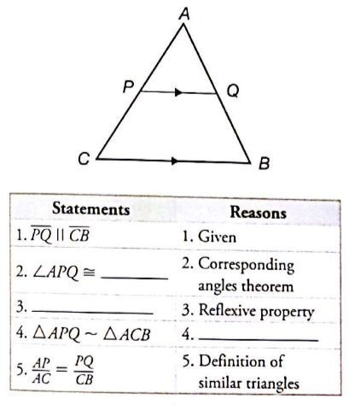

- What is the missing part of Step 2?

- ∠AQP
- ∠ABC
- ∠ACB
- ∠CPQ

- What is the missing statement for Step 3?

- ∠A ≅ ∠A
- ∠B ≅ ∠B
- ∠C ≅ ∠C
- $\overline{PQ}$ ≅ $\overline{PQ}$

- What is the missing reason for Step 4?

- SAS similarity theorem
- AA similarity postulate
- Alternate interior angles theorem
- SSS similarity postulate

- Are ΔABC and ΔDEF similar? Why or why not?
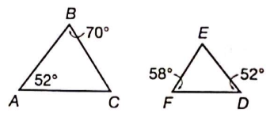

_________________________________________________________________________________________________________________________________

- The hypotenuse of a right triangle is 89 units. One leg is 39 units. What is the length of the other leg?

- 50 units
- 62 units
- 80 units
- 97 units

- A cat is stuck 15 feet up a tree. To get it down, Amanda places a ladder 5 feet from the base of the tree. How tall must her ladder be in order to reach the cat? Round to the nearest foot.

- 10 ft
- 14 ft
- 15 ft
- 16 ft

- Which of the following are not possible lengths for the sides of a right triangle?

- 6, 8, 10
- 7, 23, 24
- 8, 15, 17
- 9, 40, 41

- A rectangular classroom is 24 feet long by 18 feet wide. What is the length of its diagonal?

- 30 ft
- 32 ft
- 36 ft
- 42 ft

- To lift a heavy beam, construction workers attach a rope to the beam at the base of a building. They then run the rope over a pulley wheel at the top of the building and down to a winch on the ground 12 feet away from building, as shown below. What is the minimum length of rope needed?
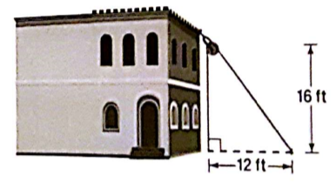

- 20 ft
- 28 ft
- 32 ft
- 36 ft

- The diagram shows the course of a bicycle race, with the start and finish at point A and checkpoints at points B and C. The participants begin the race at point A and must pass checkpoints B and C before returning to point A. What is the total length of the bicycle race course?
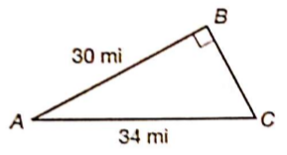

- 68 mi
- 72 mi
- 80 mi
- 109 mi

