Geometry Part 2 Name ___________________________
SOL Reporting Category 3: Polygons, Circles, and Three Dimensional Figures

Choose the best answer for each question.

Use circle O for questions 1 and 2.
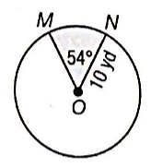
- What is the length of $\hat{MN}$?

- 1.5π yd
- 3π yd
- 10π yd
- 20π yd

- What is the area of the shaded sector?

- 15π yd²
- 25π yd²
- 47π yd²
- 85π yd²

Use the following diagram for questions 3 and 4.

A sprinkler rotates back and forth from point A to point B. The water reaches 6 meters from the base of the sprinkler.
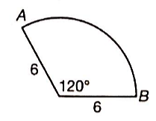
- What is the length of the minor arc AB, rounded to the nearest tenth of a meter? Use 3.14 for π.

- 6.3 m
- 9.2 m
- 12.6 m
- 31.4 m

- What is the area of the circular sector covered by the sprinkler, rounded to the nearest tenth of a square meter? Use 3.14 for π.

- 6.3 m²
- 18.8 m²
- 37.7 m²
- 94.2 m²

- The measure of an arc on a circle is 75°. If the arc has a length of 7.5π inches, what is the radius of the circle?

- 7.2 in
- 10 in
- 18 in
- 36 in

- A sector of a circle with a radius of 5 units has an area of 18.75π square units. What is the central angle of the sector?

- 75°
- 135°
- 240°
- 270°

- Circle O has a radius of 9 units. If an arc on circle O has length of 15π units, what is the measure of the arc?

- 30°
- 150°
- 215°
- 300°

- The area of the shaded region below is 84π square centimeters. What is the value of x?
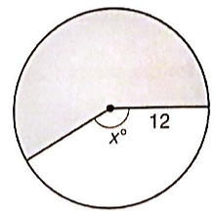

- 120
- 150
- 210
- 240

- The measure of an arc of a circle is 288°. If the radius of the circle is 10 units, what is the arc length in terms of π?

____________

- What are the coordinates of the center of the circle whose equation is (x + 4)² + (y – 1)² = 5?

- (-4, 1)
- (-4, $\sqrt{5}$)
- (4, -1)
- (4, 1)

- A diameter of a circle has endpoints (7, 6) and (7, -4). What is the equation of the circle?

- (x – 7)² + (y + 1)² = 5
- (x – 7)² + (y – 6)² = 25
- (x – 7)² + (y + 1)² = 25
- (x – 7)² + (y – 1)² = 25

- Which of the following is the graph of (x + 2)² + (y – 1)² = 4?
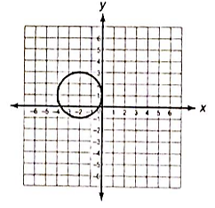
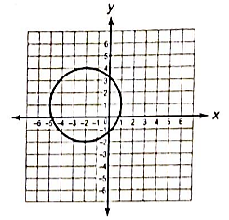
- . C.

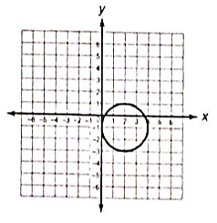
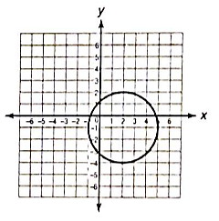
- . D.

- The point (9, 2) lies on a circle with center (5, -2). What is the radius of the circle?

- 4
- $4\sqrt{2}$
- $2\sqrt{53}$
- 32

- Which of the following points does not lie on the circle given by the equation x² + (y – 8)² = 81?

- (-9, 8)
- (0, -1)
- (9, 8)
- (9, -1)

- What is the equation of circle O, as shown in the figure below?
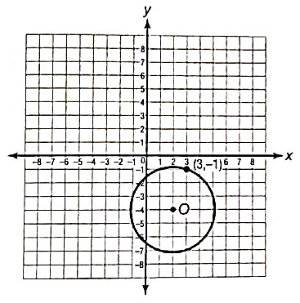
- (x + 2)² + (y – 4)² = 10
- (x + 2)² + (y – 4)² = $\sqrt{10}$
- (x – 2)² + (y + 4)² = 10
- (x – 2)² + (y + 4)² = $\sqrt{10}$
- What is the diameter of the circle given by the equation (x – 8)² + (y – 4)² = 14?

- $\sqrt{14}$
- $2\sqrt{7}$
- $2\sqrt{14}$
- 28

- Which of the following is true about the two circles given by the equations below?
(x + 7)² + (y – 3)² = 12
(x – 7)² + (y – 3)² = 12

- The two circles have the same center.
- The two circles overlap in the coordinate plane.
- One circle has a greater area than the other.
- The two circles have the same radius.

- The point (8, -5) lies on a circle with center (3, -2). Write the equation of the circle.

___________________________________________

- The dimensions of a baseball are shown below. What is the surface area of the baseball?
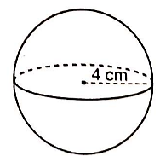
- 4π cm²
- 16π cm²
- 64π cm²
- 68π cm²

- A wooden block has the dimensions shown below. What is the total surface area of the wooden block?
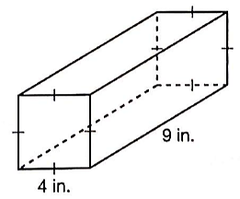

- 68 in.²
- 104 in.²
- 152 in.²
- 176 in.²

- A cylindrical pedestal on the set of a television show has a radius of 3 feet and a height of 2 feet. What is the total surface area of the pedestal?

- 12π ft²
- 18π ft²
- 30π ft²
- 45π ft²

- Which is closest to the total surface area of the cone below?
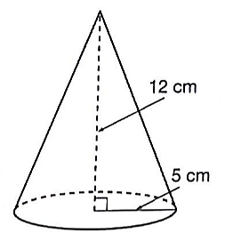

- 204.1 cm²
- 219.8 cm²
- 266.9 cm²
- 282.6 cm²

- A right pentagonal pyramid has a slant height of 7 centimeters. The pyramid’s base is a regular pentagon with sides measuring 2 centimeters. Which is the closest to the lateral area of the pyramid?
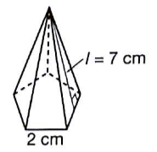

- 7 cm²
- 14 cm²
- 35 cm²
- 70 cm²

- The figure below represents a right pyramid on top of a cube. Which is closest to the total surface area of the figure?
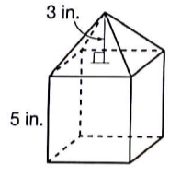

- 155 in.²
- 164 in.²
- 180 in.²
- 189 in.²

- An ice cream cone is shown below. What is the volume of the cone?
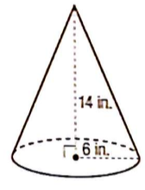

- 56π in.³
- 168π in.³
- 504π in.³
- 672π in.³

- A spherical juggling ball is shown below. What is the volume of the juggling ball to the nearest cubic centimeter?
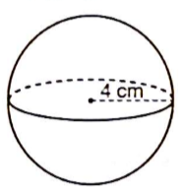

- 50 cm³
- 67 cm³
- 134 cm³
- 268 cm³

- A display case in a museum has the shape of a square pyramid, as shown below. What is the volume of the display case?
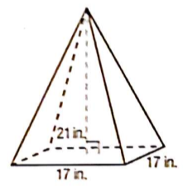

- 238 in.³
- 476 in.³
- 2,023 in.³
- 6,069 in.³

- What is the volume of the prism shown below?
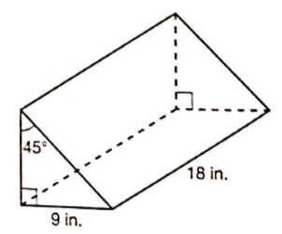

- 364.5 in.³
- 729 in.³
- $729\sqrt{2}$ in.³
- $729\sqrt{3}$ in.³

- Which is the best estimate for the volume of the largest cone that would fit inside the cylinder shown below?
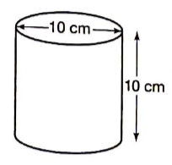

- 262 cm³
- 393 cm³
- 785 cm³
- 1,047 cm³

- Rose bought a small tent for her pet rabbit. The tent is in the shape of a square pyramid, as shown below. The base has side lengths of 18 inches. The lateral faces have a slant height of 15 inches. What is the volume of the tent?
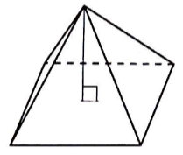

- 324 in.³
- 405 in.³
- 1,296 in.³
- 1,620 in.³

- The volume of a rectangular prism is 560 cubic centimeters. If the length of the prism is 10 centimeters and its width is 8 centimeters, what is its height?

- 6 cm
- 7 cm
- 8 cm
- 9 cm

- A gemstone is shown in the figure below. It is composed of a cube with edges of 12 centimeters and a square pyramid with height of 10 centimeters. What is the volume of the gemstone?
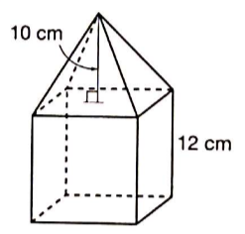

- 2,208 cm³
- 2,448 cm³
- 2,476 cm³
- 3,168 cm³

Use these figures for questions 33 and 34.
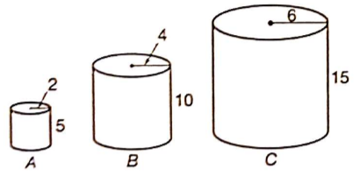

- How does the volume of cylinder C compare to the volume of cylinder A?

- It is 3 times the volume of cylinder A.
- It is 8 times the volume of cylinder A.
- It is 9 times the volume of cylinder A.
- It is 27 times the volume of cylinder A.

- How does the total surface area of cylinder B compare to the total surface area of cylinder A?

- It is 2 times the surface area.
- It is 4 times the surface area.
- It is 8 times the surface area.
- It is 16 times the surface area.

- The figure below shows two regular hexagons. The area of the smaller hexagon is 5.85 cubic centimeters. The area of the larger hexagon is 146.25 cubic centimeters. What is the value of x?
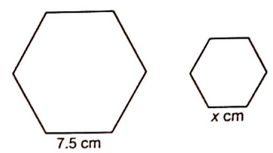

- 0.3
- 1.5
- 5
- 7.5

- A golf ball and a soccer ball are both spherical. The volume of the soccer ball is approximately 905.04 cubic centimeters. The volume of the golf ball is 4.19 cubic centimeters. Which of the following best describes the relationship between the radii of the two spheres?

- The soccer ball has 6 times the radius of the golf ball.
- The soccer ball has 15 times the radius of the golf ball.
- The soccer ball has 72 times the radius of the golf ball.
- The soccer ball has 216 times the radius of the golf ball.

- The figure below represents cheese cubes sold at a gourmet shop. By what factor is the volume of the larger cube greater than the volume of the smaller cube?




