Name:__________________________
final unit 2 test preparation HW
Date________________Block_______
- Go to https://www.ixl.com.
- Sign in with the following:
- Username: Your student ID#@vbschools
- Password: The first 2 lowercase letters of your last name followed by your student ID#
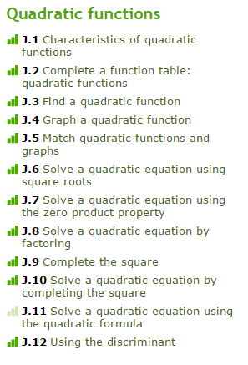
- Go to the red A2 tab, which are all Algebra 2 concepts.
- Go to the Quadratic functions section (on the right).
- I would suggest that you practice most of the concepts given, but some of them might not be as high of a priority as others in terms of what areas you need to focus on. In order to receive a 3 on your homework, you must get a score of 80% or above on at least 3 of the concepts from J.6 to J.11
- Have loose-leaf paper out and write the IXL number at the top. Number the problems and show your work neatly for problems that require it.
- On the day of the test, you will turn the following:
- Unit 2 Test Review Worksheet
- More Solving Quadratics Worksheet
- What do you know about Quadratics Worksheet
- Final Unit 2 Test Preparation IXL work on loose-leaf
- Good Luck! You will not have much time to go over questions on the day of the test. Make sure you come to class prepared! If you take too long to complete your test, you must finish it on the day it is given. You may not come back the next day! The more you practice, the less time it will take you to do problems and the more time you will have to check over your work!

