**Practice working with Parallel Lines and Angles Name______________________**

**Date______________Block____**

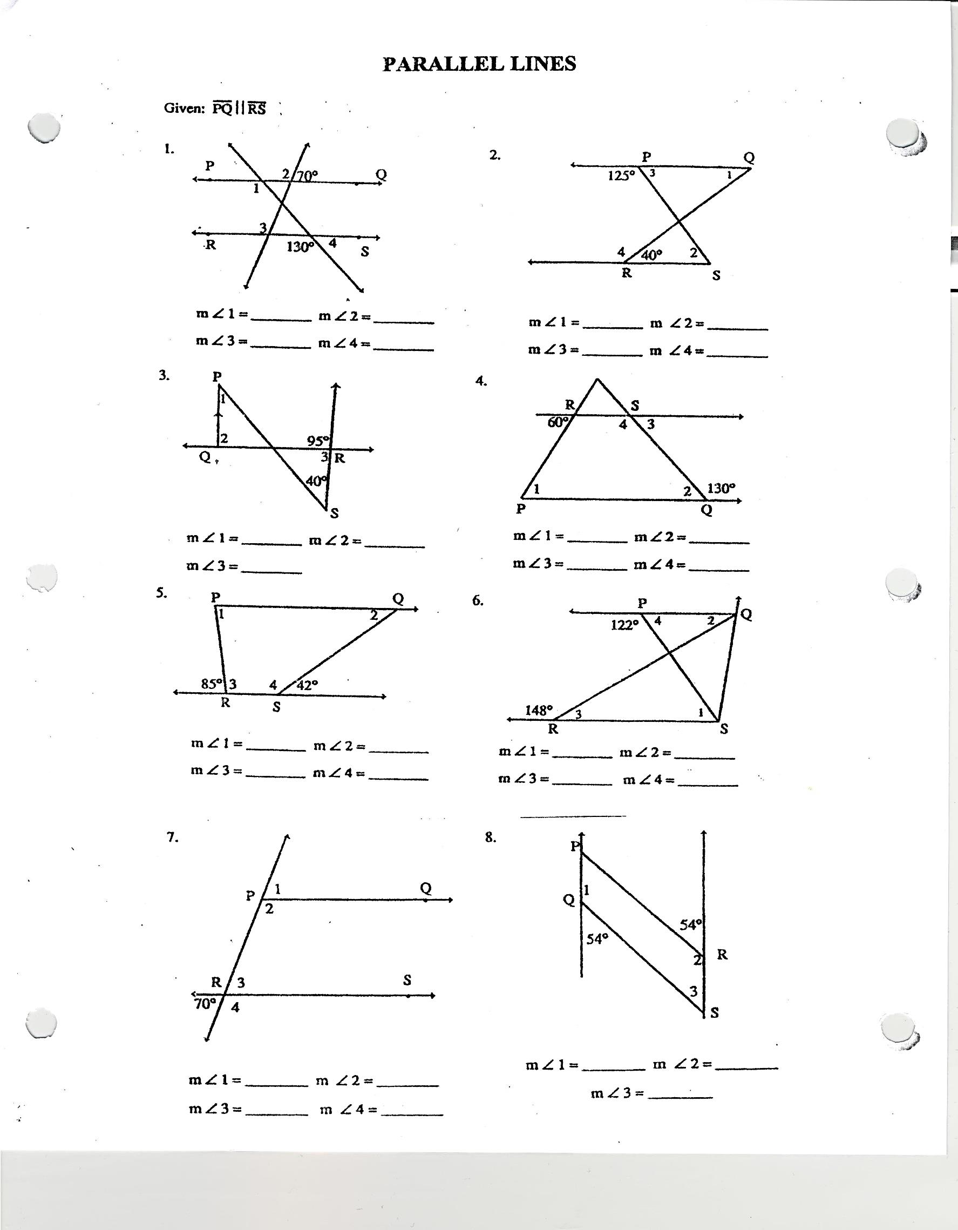**1-8: If , find the measure of each angle.**

**Given: l || m || n and p || g. Find the measures of the numbered angles.**

