Review 8-2 to 8-3
Write irrational answers in simplified radical form AND in decimal form rounded to the nearest tenth.

Name_________________________
Date________________Block_____
Pythagorean Theorem: a² + b² = c² Find x.
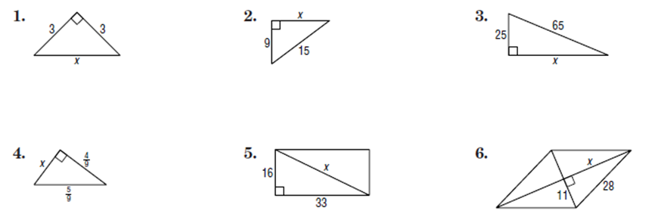

Converse of the Pythagorean Theorem: Determine whether each set of measures can be the sides of a right, obtuse, or acute triangle. If it is a right triangle, then state whether the sides form a Pythagorean Triple.

7. 30, 40, 50 8. 20, 30, 40 9. 18, 24, 30

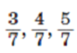
10. 6, 8, 9 11. 12. 10, 15, 20

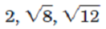
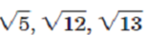
13. 14. 15. 9, 40, 41

Pythagorean Triples: A family of Pythagorean triples consists of multiples of known triples. For each Pythagorean triple, find two triples in the same family.
16. 3, 4, 5 17. 5, 12, 13 18. 7, 24, 25

Application Problem:

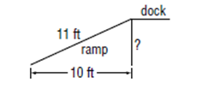
19. The bottom end of a ramp at a warehouse is 10 feet from the base of the main dock
and is 11 feet long. How high is the dock?

Special Right Triangles: 30° - 60° - 90° Find x and y.
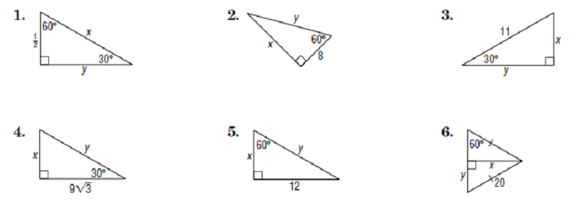
25.
24.
23.
22.
21.
20.

26. The perimeter of an equilateral triangle is 32 cm. Find the length of an altitude of the triangle to
the nearest tenth of a centimeter.

27. An altitude of an equilateral triangle is 8.3 meters. Find the perimeter of the triangle to the
nearest tenth of a meter.

Special Right Triangles: 45° - 45° - 90° Find x.
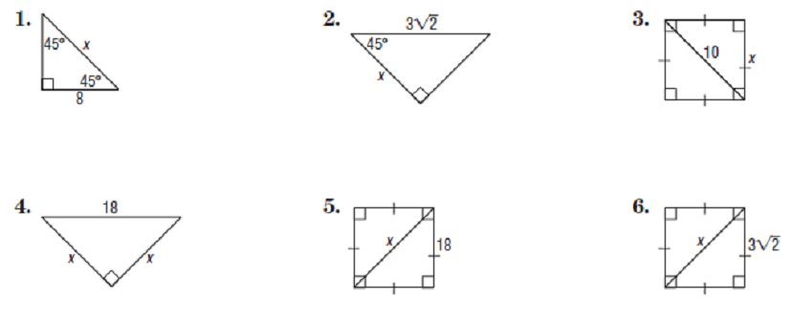
30.
29.
28.

32.
31.
33.

34. Find the perimeter of a square with a diagonal that measures 12 centimeters.

35. Find the diagonal of a square with a perimeter of 20 inches.

