Name: _______________________

Date: ____________ Block: _____

- Go to http://regentsprep.org/.
- Click on Algebra (Fig. 1)
- Click on #2 - Operations (Fig. 2)
- Click on Radicals.
- Go through the 3 Lessons about Radicals (Fig. 3). Check off the boxes below indicating that you did each one.
- Do the Practice Section (Fig. 3)
- Copy down the 12 Practice Problems and the work used to get the answers on loose-leaf paper. Do the problem in pencil. Then check your answer and if it is wrong, try and find the right one. Write your correction next to your problem when you find the correct solution.

Fig. 1 Fig. 2: Operations Fig. 3
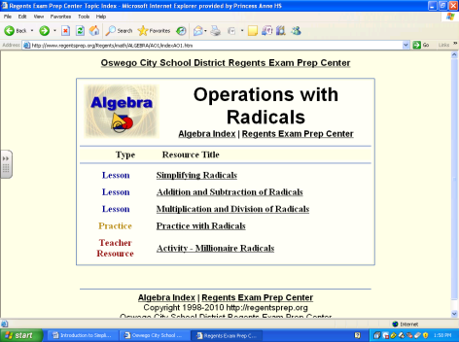
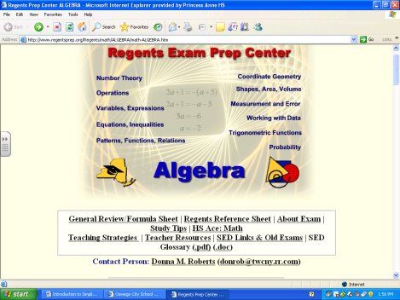
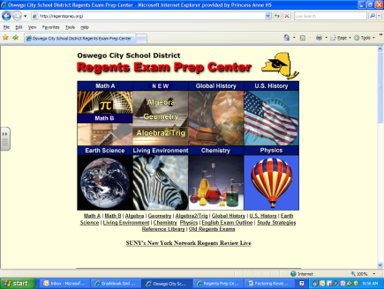

- Lesson | Simplifying Radicals
- Lesson | Addition and Subtraction of Radicals
- Lesson | Multiplication and Division of Radicals
- Practice | Practice with Radicals

- Go to #6 – Trigonometric Functions.
- Click on Pythagorean Theorem.
- Go through the Lesson titled Pythagorean Theorem. Check off the box below when completed.
- Do the Practice Section.
- Copy down the 11 pictures from the Practice Problems and show the work used to get your answers. Then click on the answer and correct your work in pen.

- Lesson | Pythagorean Theorem
- Practice | Practice with Pythagorean Theorem

