**Unit 5 (Chapter 7) Test Review Name_____________________________**

*Round all decimals to the nearest tenth.*  **Date_________________Block________**

**OBJ: Be able to identify and define the following geometry words.**

**1.** What is a ratio?

**2.** What is a Proportion?

**3.** What are Cross products?

**4.** What is the Scale factor?

**5.** What is the difference between Congruent Polygons and Similar Polygons?

**OBJ: Be able to solve a proportion.** *Find the value of x. SHOW ALL WORK.*

**6.**  **7.**  **8.** 

**OBJ: Be able to find all parts of similar polygons.** *Given: ABCD ~ EFGH*

B

8

5

A

D

4

C

60°

**9.** Write the proportionality statement using only letters.

**10.** Rewrite the proportionality statement by substituting in numbers from the figures.

H8

E

2

F

G

6

**11.** The scale factor of ABCD to EFGH is ______________.

**12.** The ratio of the perimeter of EFGH to the perimeter of ABCD is ______________.

**13.** m∠F = ______________ **15.** FG = ______________

**14.** m∠H = ______________ **16.** AB = ______________

**17.** HG = ______________

**OBJ: Be able to identify similar triangles, state why they are similar, and write a similarity statement.**

*Determine whether the 2 triangles shown are similar (Circle Yes or No). SHOW WORK TO JUSTIFY YOUR ANSWER!*

*If Yes, state why they are similar (AA~, SAS~, or SSS~) and write the triangle similarity statement.*

F

6

D

8

M

10

5

4

3

G

V

A

N

H

T

B

U

**18.** **19.**

Yes No Why:______________ Yes No Why:_____________

Δ____________ ~ Δ____________ Δ____________ ~ Δ__________

W

D

Y

R

X

G

D

12

10

T

R

A

O

4

6

20°

70°

90°

20°

**20.** **21.** **22.**

Yes No Why:______________ Yes No Why:______________ Yes No Why:_____________

Δ____________ ~ Δ____________ Δ____________ ~ Δ____________ Δ___________ ~ Δ___________

**OBJ: Be able to write a proportion when given a picture and solve for the variable.**

*Find the value of x in each problem. SHOW ALL WORK!*

**23.** ___________ **24.** ___________ **25.** ___________

18

x - 4

x - 5

15

12

5

3

X

(

(

6

x

10

8

**26.** ___________ **27.** ___________ **28.** ___________

6

6

4

X

8x

5

60

3

5

4

(

(

)

)

X

15

**29.** ___________ **30.** ___________ **31.** ___________

4

2

X

6

X

3

4

6

18

4

12

X

**32.** ___________ **33.** ___________ **34.** ___________

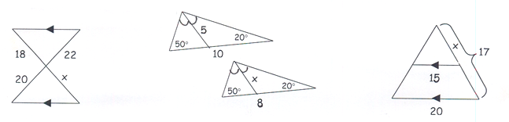

**35.** ___________ **36.** ___________ **37.** ___________

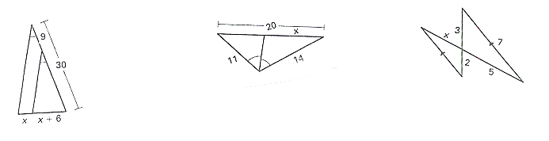

**38.** ___________ **39.** ___________ **40.** ___________

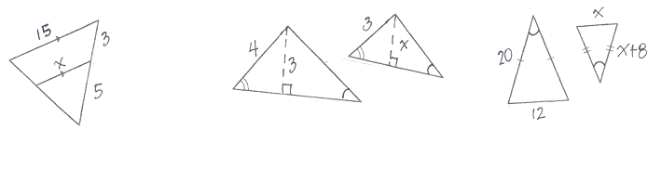

**OBJ: Be able to find midsegments.** *Find the value of x in each problem. SHOW ALL WORK!*

**41.** ___________ **42.** ___________

24x - 36

F

E

D

B

A

6x

W

D

Y

R

Z

26

X

**OBJ: Be able to solve a word problem using proportions.** *Solve each word problem below. First draw and label each picture with the information given. Then write a proportion to find your variable.*

1. The ratio of one side of ΔMNO to the corresponding side of similar ΔPQR is 1 : 4. **43. _________________**

If the perimeter of ΔPQR is 100 inches, what is the **perimeter** of ΔMNO?

1. A card that is 5 inches wide and 12 inches high was enlarged **44. _________________**

to be 12 inches wide. How **high** is the enlargement?

1. Evan bought a 13 inch scale model of a sculpture in an art museum. **45. _________________**

If the ratio of the height of the scale model to the height of the sculpture

is 2: 5, then find the height of the sculpture.